BASICS

Terminal Codes

- xinput list - List of devices
- xinput float [] - remove device
- xinput reattach [] [] - reattach device
- whoami - user name
- echo “sample” - print sample
- echo $SHELL - type of shell currently using
- clear (Ctrl + L) - clear the terminal
- history - view all command history
- history [10] - view last 10 command history

Directory Manipulation
- pwd - print working directory
- ls - list files in the current directory
- ls c* - list items starts with “c”
- ls [-a] - show hidden files and directories
. - current directory
.. - parent directory
- ls [-l], ls [-al] - view file or folder (show details)
- cd , cd ~ - home directory
- cd / - root directory
- cd - - previous directory
- cd . - change to current directory
- cd .. - change to parent directory
- cd ../.. - change to grand parent directory
- cd /home - change directory by absolute path

File Manipulation
- mkdir dep - make directory “dep”
- mkdir “dep 10” - make directory with spaces
- rm file_name - remove file
- rm -r folder_name - remove folder
- mv old_folder/file_name new_name - rename folder or file
- touch file_name - create empty file
- nano text_file_name - open text document using nano. (text viever in UNIX)
- cp existing_file_path&name new_file_path&name - copying file
- cp -r folder_name&path new_path&name - copying folder
- mv file/folder_directory&name existing_directory_path - move file or folder

Permisions
- sudo …. - temporary root access for the following code
- sudo su - start sudo session
- exit - exit sudo session
- chmod permission file/folder - change folder/file permission
  - permission – 700, 600, 500, 300
- chown user_name file_name - change ownership of a file
- chown -R user_name folder_name - change ownership of a folder

Softwares to be installed

- JDK 17 (/opt/java/jdk-17)
- JDK 11 (/opt/java/jdk-11)
- JDK 8 (/opt/java/jdk-8)
- NodeJS (/opt/nodejs/nodejs-18)
- Apache Maven (/opt/apache/apache-maven-3.x.x)
- intellij IDEA Ultimate (/opt/jetbrains/itellij-idea)
- DataGrip ((/opt/jetbrains/data-grip)
- VS Code (/opt/vscode)
- MySQL (apt install mysql-server)
- Java FX Scene Builder

Installations
Editing “/home/gayashan/.profile” or “/etc/profile” is not recommended here as we need to use multiple java versions in the system.

If we need to use multiple software versions in the operating system don’t set the environment variables.

Therefore, use the following method. (“code” is used for VSCode in following sample)

sudo update-alternatives -- install /usr/bin/code code installation path (executable path) 1
{update-alternatives} -
{--install} -
{usr/bin/code} - Shortcut path, where the executable files are stored (usr/bin)
{code} - The command, that want to be added as syntax to run in terminal
{installation path} - The path of the extracted file’s executable file
1 - priority number

To check the previous update-alternavies relative to “java”, use:
update-alternatives --list javac
update-alternatives --list java

To change the version of java used in the operating system, use the following command,
sudo update-alternatives --config java

JAVA

Compiling the .java file

javac -cp . Demo.java

If class path is similar to . (working directory) the ( -cp . ) part is optional.

Running .class file by JVM

java Demo

GIT

Initialize git
git init

Set username and email for git
git config --global user.name "Gayashan_Dananjaya"
git config --global user.email "gayashandananjaya3@gmail.com"

View my git confguration file

git config --list

You can use the git config –list command to see all the configuration values that are associated with your particular Git installation.

Git config: configuration levels

Configuration values can be set at three different levels:

–local:
Local values will be applied to the repository in which the git config command is executed. These values are stored in .git/config inside a repository.

–system:
System values are applied to all users on a machine. You should set system-level configuration values with caution because it may alter existing configurations. These values are stored in /etc/gitconfig on Linux.

–global:
Global values are applied to a particular user on an operating system. They are stored within the ~/.gitconfig file in your home directory.

When you’re first setting up Git, you’ll mostly use the –global level.

Cloning (Download) github repository

git clone [url]

Clone (download) a repository that already exists on GitHub, including all of the files, branches, and commits.

Check the git staging environment
git status

Add files to the staging environment
git add --all Stage all changed (new, modified, and deleted) files.
git add -A
git add index.html (adding specific file)

Commiting from staging environment to the repository
git commit -m “Type your message here”

Commiting without the staging environment
git commit -a -m “Type your message here”

Checking the created git branches
git branch

Creating a new git branch (whie staying at the previous branch)
git branch branch-name

Switching to an existing branch
git switch branch-name
git checkout branch-name

Creating and switching to a newly created branch
git checkout -b branch-name (branch created from the current branch)
git checkout -b NEW_BRANCH [FROM_BRANCH]
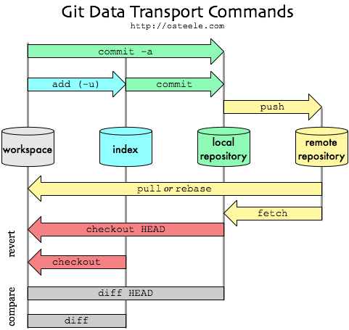

Renaming branch
git branch -m new_name (renaming the current branch)
git branch -m old_name new_name (renaming a different branch)

Merging a branch to master
1. switch to master branch
2. git merge branch-name

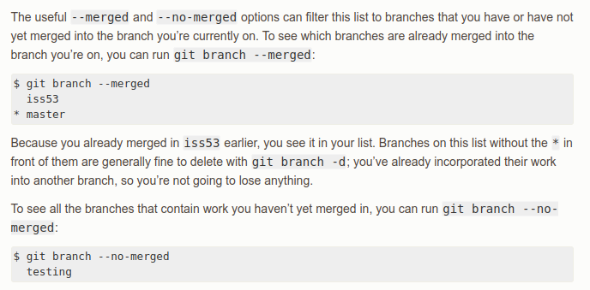

Deleting a branch
git branch -d branch-name

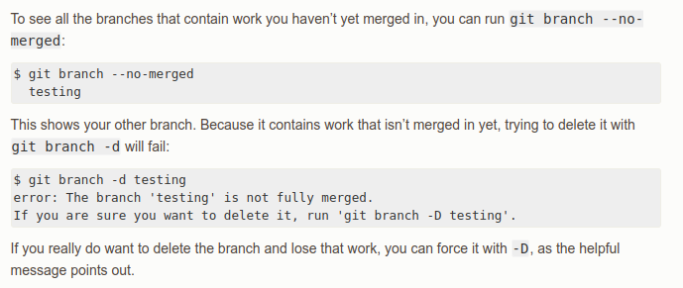

Setting an upstream branch
git remote add origin https://github.com/hello-world.git

This specifies that you are adding a remote repository, with the specified URL, as an origin to your local Git repo.

Saving the username and password credentials to github to be used automatically
git config --global credential.helper store

The point of this helper is to reduce the number of times you must type your username or password. For example:
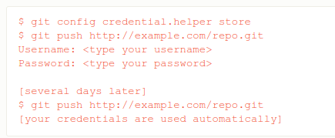

Setting an upstream branch
git push --set-upstream origin <branch>
git push -u origin <branch> (Shortened version)

<branch> : The local git branch, that need to push

The easiest way to set an upstream branch is to use the "--set-upstream" option when pushing the branch to the remote repository for the first time. This relationship is very helpful for two reasons.

1st reason;
Push and pull become a lot easier. With an upstream branch set, you can simply use the shorthand commands "git pull" and "git push" - instead of having to think about the exact parameters like in "git push origin development".

2nd reason;
Git can now also tell you about unsynced commits which you haven't pushed or pulled, yet. Here's an example.

(a) if you have 2 commits in your local repository which you haven't pushed to the remote yet, then your local branch is "2 commits ahead" of its upstream branch.
(b) if there are 4 commits on the remote upstream branch which you haven't pulled yet, then your local branch is "4 commits behind" its upstream branch.

Pulling a branch from github (not saved in local git)
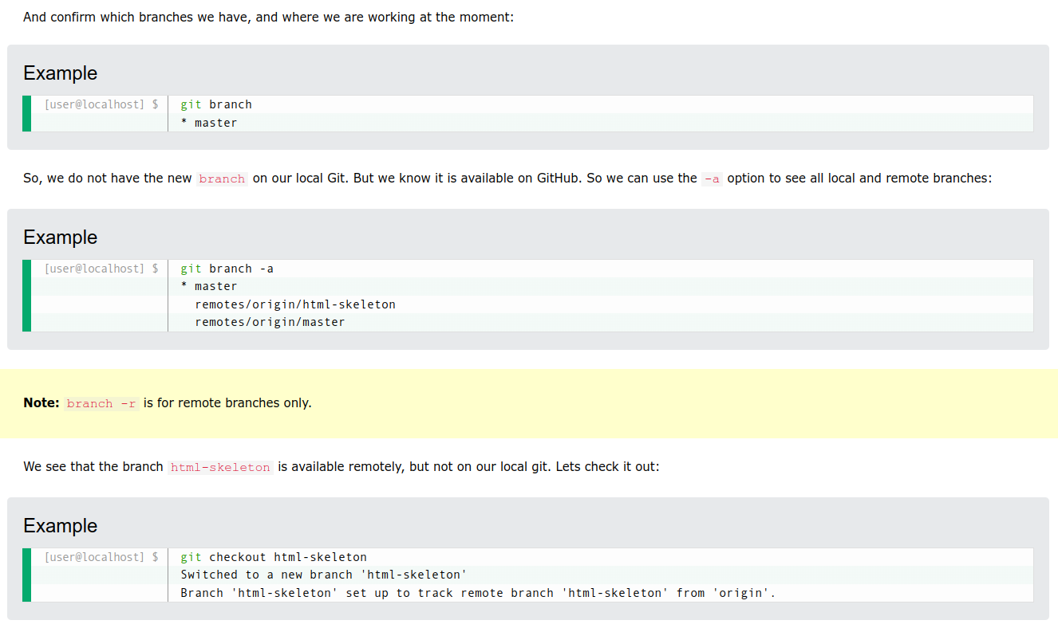
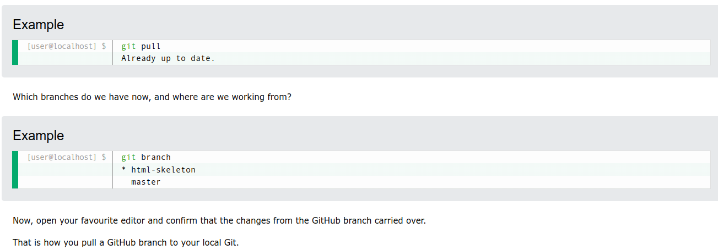
git pull = git fetch + git merge

git pull: Updates your current local working branch with all new commits from the corresponding remote branch on GitHub

Pushing a new branch to github

git push origin branch-name
(branch name is the git branch name and same name branch will be crated in github)

Cloning a github repository to git

git clone [url]

Clone (download) a repository that already exists on GitHub, including all of the files, branches, and commits.

URL

https://www.google.com/maps/place/Panadura/@6.71238,79.9024813,17z/data=!3m1!4b1!4m6!3m5!1s0x3ae24616f9ff0341:0x1205cc00554901e1!8m2!3d6.71238!4d79.90467!16s%2Fg%2F1vq9kq8v

https = protocol
www = sub domain
google = domain name
com = top level domain
/maps = path segment
/place = path segment
/Panadura = path segment
/@6.71238,79.9024813,17z/data=!3m1!4b1!4m6!3m5!1s0x3ae24616f9ff0341:0x1205cc00554901e1!8m2!3d6.71238!4d79.90467!16s%2Fg%2F1vq9kq8v.

MYSQL

+ Check status of mysql database server

service mysql status

+ Start mysql database server

service mysql start

+ Stop mysql database server

service mysql stop

+ For any type of database use the following commands

systemctl status <dbservername>
service <dbservername> status

systemctl start <dbservername>
service <dbservername> start

systemctl stop <dbservername>
service <dbservername> stop

systemctl restart <dbservername>
service <dbservername> restart

+ Connect to mysqld (mysql server) from mysql client

mysql -h 127.0.0.1 --port 3306 -u root -p
enter password here

mysql --port 3306 -u root -p (If accessing server from the same computer)
enter password here

mysql -u root -p (If accessing server from the same computer & port is not changed from the default 3306)
enter password here

When error occurs entering the password, do the following

1. sudo mysql
2. UNINSTALL COMPONENT 'file://component_validate_password';
3. ALTER USER 'root'@'localhost' IDENTIFIED WITH mysql_native_password BY 'Enter your password here';
4. FLUSH PRIVILEGES;
5. exit

+ To remove mysql
sudo apt remove mysql*
sudo rm -rf /var/lib/mysql

MySQL Specific Commands

[] - Optional
<> - Necessary

1. List databases

SHOW DATABASES;

2. Switch between databases

USE <dbname>;

3. Show currently selected database

SELECT DATABASE();

4. Create database

CREATE DATABASE <dbname>;

5. Remove database

DROP DATABASE <dbname>;

6. Show tables in a database

SHOW TABLES;

7. Describe table

DESCRIBE <table_name>;
EXPLAIN <table_name>;

SQL Commands

[] - Optional
<> - Necessary

1. SQL - Create Table

CREATE TABLE [IF NOT EXISTS] <table_name> (
<column_name> <data type> [DEFAULT <value>] [column constraints],
<column_name> <data type> [DEFAULT <value>] [column constraints],
<column_name> <data type> [DEFAULT <value>] [column constraints],
<column_name> <data type> [DEFAULT <value>] [column constraints],
);

column constraints → PRIMARY KEY (Should be unique and not empty)
NOT NULL (Should be not empty)

2. SQL – Delete Table

DROP TABLE [IF EXISTS] <table_name>;

3. SQL – Describe Table

DESCRIBE <table_name>;

4. SQL – Insert record into Table

INSERT INTO <table_name> [(column1, column2,…)]
VALUES (value1, value2, DEFAULT, …)
(value1, value2, DEFAULT, …)
(value1, value2, DEFAULT, …);

5. SQL – Update Table Record

UPDATE <table_name> SET <column_name>=<value>, <column_name>=<value> WHERE <boolean expression>;

boolean expression gets executed against every row, when true that row gets update
“AND” , “OR” could be used, which are standatd sql syntaxes

6. SQL – Delete Table Record

DELETE FROM <table_name> WHERE <boolean expression>;

7. SQL – Delete All Table Record

TRUNCATE <table_name>;

Table 1: Comparison of "Delete" and "Truncate" commands
DELETE | TRUNCATE
Condition is required | No condition is required
Won’t change table structure | Recreate table structure  (DROP and CREATE again the table)
Record will be deleted, even if the table has relationships | Cannot delete when the table has a relationship (Due to recreation of table)

8. SQL – Select

SELECT <identifier1 | value>, <identifier2 | value> [AS alias], … [FROM <table_name> [AS alias], <table_name>];

Examples

- SELCT 10, 15;
- SELECT * FROM Student;
- SELECT * FROM Student, Course;
- SELECT s.*, c.id, ‘IJSE’ AS ‘col’ FROM Student AS s, Course as c;

